Reflexology Case Study

Client Consultation Form

Student name: | ______________________________
Student number: | _____________
College name: | Holistic College Dublin
Client name: | _______________________________

CLIENT CONSULTATION FORM

Name: ________________________________________________________________
Address: ______________________________________________________________
Tel.: (H) ________________ (W) ________________ (M) ______________________

Date of Birth ____/____/_______

Medical History:
Do you have any of the following conditions? Please indicate Yes (✓)or No (X)

Contraindications that require medical permission
Asthma |  | Inflamed nerve
Any Condition being treated by GP or other Complimentary Therapist |  | Motor Neurone Disease
Blood Clot - Thrombosis |  | Medical Oedema
Blood Pressure -High (hypertension) |  | Muscular Sclerosis (MS)
Blood Pressure -Low (hypotension) |  | Parkinson’s Disease
Inflamed Vein - Phlebitis |  | Nervous / Psychotic conditions
Heart conditions |  | Osteoporosis
Cancer |  | Pregnancy
Skin cancer |  | Prescribed medication
Diabetes |  | Recent operations
Epilepsy |  | Sciatica
Joint disorders (Arthritis) |  | Spastic conditions
Acute rheumatism |  | Trapped/Pinched nerve
Kidney infections |  | Undiagnosed pain

Contraindications that restrict treatment
Abrasions/broken skin |  | Recent fracture (min. 3 months)
Bruising (haematoma) |  | Scar tissue
Contagious or infectious diseases |  | Skin diseases
Cuts / Open wounds |  | Slipped disc
Diarrhoea |  | Sunburn
Fever |  | Under the influence of alcohol/drugs
Inflammation |  | Undiagnosed lumps/bumps
Localised swellings |  | Varicose veins
Pregnancy (1st trimester) |  | Vomiting

Other Conditions
Allergies |  | Headaches / Migraines
Bloating |  | Irregular Menstrual Cycle
Cold Hands or Feet |  | Muscular Aches
Constipation |  | Sinus Congestion
Dandruff (Pityriasis Capitis) |  | Stiff Joints
Depression |  | Stress
Digestive Disorders |  | Tired Legs/Feet
Fluid Retention |  | Thread veins

If you have answered yes to any of the above, give details: ____________________
______________________________________________________________________
______________________________________________________________________
______________________________________________________________________

Current Medication? ___________________________________________________

Doctor’s name: _________________________________ Tel: ___________________
Lifestyle

Do you exercise: _______________ How frequently: _______________________

What type of exercise/sport: _________________________________________________

Do you get fresh air: _____________ Hours per day: ________________________

Do you have a healthy diet: _______

How many portions do you eat per day of the following:

Fresh fruit: ______ Fresh vegetables: ______ Protein: _____ Source? _____________
Dairy produce: _____ Sweet things: ______ Added salt: ______ Added sugar: ______

How much of the following do you drink per day:

Water: __________ Tea: __________ Coffee: __________ Alcohol (per week): _______

Do you smoke: _________ If yes, how many per week: ___________________________

Is your sleep, very good, good, fair, or poor: ____________________________________

What do you do to relax (yoga, meditation etc.): _________________________________
__________________________________________________________________________

Do you have other hobbies or interests: ________________________________________
__________________________________________________________________________

Is your work active or sedentary: _____________________________________________

Do you work at a computer: ________ If yes, how many hours per day: ____________

On a scale of 1 to 10, (1 being lowest) how do you rate your stress levels at

work: __________________________ and at home: ______________________________

Personal Information
Circulation | Tired Legs |  | Cold Hands/Feet |  | Cellulite
Immune System | Prone to Sore Throats |  | Colds |  | Chest Infections
 | Sinus Infection
Gynaecological | Irregular Periods |  | PMT |  | Menopause
 | HRT |  | Pill |  | Coil
Other
Nervous System | Depression |  | Stress |  | Tension
Digestive System | Heartburn |  | Stomach Problems |  | Constipation
Skin Type | Normal |  | Dry |  | Oily
 | Combination |  | Sensitive |  | Dehydrated
Skin Condition | Dermatis |  | Eczema |  | Psoriasis

Client Profile

Date of Birth: ___/___/______

_______________________________________________________________
_______________________________________________________________
_______________________________________________________________
_______________________________________________________________
_______________________________________________________________
_______________________________________________________________
_______________________________________________________________
_______________________________________________________________

Treatment plan:

_______________________________________________________________
_______________________________________________________________
_______________________________________________________________
_______________________________________________________________
_______________________________________________________________
_______________________________________________________________
_______________________________________________________________
_______________________________________________________________

Therapist’s signature: ________________________________

Client’s signature: ___________________________________
Reflexology Treatment No: _____ Date: _______________

Reading the feet:

Texture: ______________________________________________
______________________________________________
Temperature: ______________________________________________
______________________________________________
Colour: ______________________________________________
______________________________________________
Smell: ______________________________________________
______________________________________________
Tone: ______________________________________________
______________________________________________
Flexibility: ______________________________________________
______________________________________________
Skeletal structure: ______________________________________________
______________________________________________
______________________________________________
______________________________________________
Condition of nails: ______________________________________________
______________________________________________

How treatment was conducted and tender reflexes found: _______________________
______________________________________________________________
______________________________________________________________
______________________________________________________________
______________________________________________________________
______________________________________________________________
______________________________________________________________

How client felt before the treatment: _________________________________________
______________________________________________________________
______________________________________________________________
______________________________________________________________

Client’s reaction during treatment: __________________________________________
______________________________________________________________
______________________________________________________________
______________________________________________________________

Client’s reaction after treatment including after care advice: ____________________
______________________________________________________________
______________________________________________________________
______________________________________________________________
Home care advice: ________________________________________________________
______________________________________________________________
______________________________________________________________
______________________________________________________________
______________________________________________________________
______________________________________________________________
______________________________________________________________

Recommendations for self treatment: ________________________________________
______________________________________________________________
______________________________________________________________

Reflective practice: _______________________________________________________
______________________________________________________________
______________________________________________________________
______________________________________________________________
______________________________________________________________

Therapist’s signature ______________________________________

Client’s signature ______________________________________
Foot Map – Treatment No: _____ Date: ____________

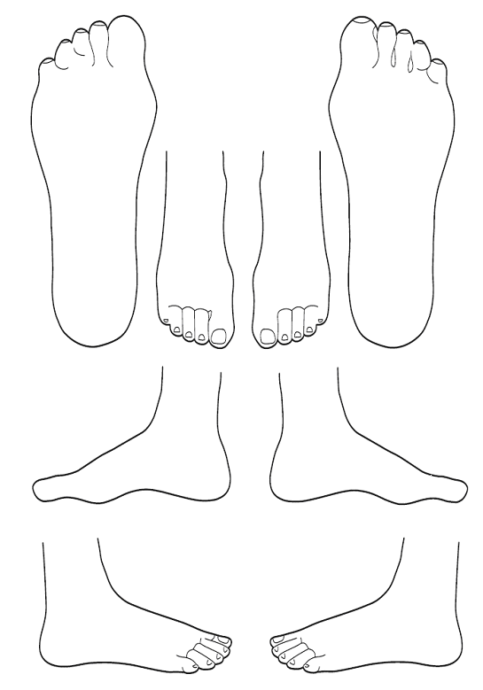
Reflexes |  | Skin Texture |  | Skeletal Problems
Slightly Tender |  | Hard skin |  | High Arches | ↑
Very Tender | ↓ | Taut skin | ||||| | Low Arches | ↓
Hard | ◻ | Dry/cracked skin |  | Skeletal Deformities | 
Gritty |  | Infections | ◆
Puffy | ⬇ | Damp | ○
 |  | Freckles | '
Overall conclusion of the case study: _________________________________________
______________________________________________________________
______________________________________________________________
______________________________________________________________
______________________________________________________________
______________________________________________________________
______________________________________________________________
______________________________________________________________
______________________________________________________________
______________________________________________________________
______________________________________________________________
______________________________________________________________
______________________________________________________________
______________________________________________________________
______________________________________________________________
______________________________________________________________
______________________________________________________________
______________________________________________________________
______________________________________________________________
______________________________________________________________
______________________________________________________________
______________________________________________________________
______________________________________________________________
______________________________________________________________
______________________________________________________________
______________________________________________________________
______________________________________________________________
______________________________________________________________
______________________________________________________________
______________________________________________________________
______________________________________________________________
______________________________________________________________
______________________________________________________________
______________________________________________________________
______________________________________________________________
______________________________________________________________
______________________________________________________________



Consent to a Reflexology treatment

I understand that I am receiving treatment from a student of the Holistic College Dublin and that they are not a qualified therapist.

I accept that these notes will be viewed by the course instructor and an independent examiner.

I declare that the information I have given is correct and that I have been fully informed about any contra-indications, and I am willing to proceed with the treatment.

I enter this agreement freely and will not hold the student or instructor responsible should the treatments fail to have a positive result.

Client’s Name………………………… Signature ……………………………

Student’s Name ……………………………… Date ………………………….

