Hand Map – Treatment No: _____ Date: ____________
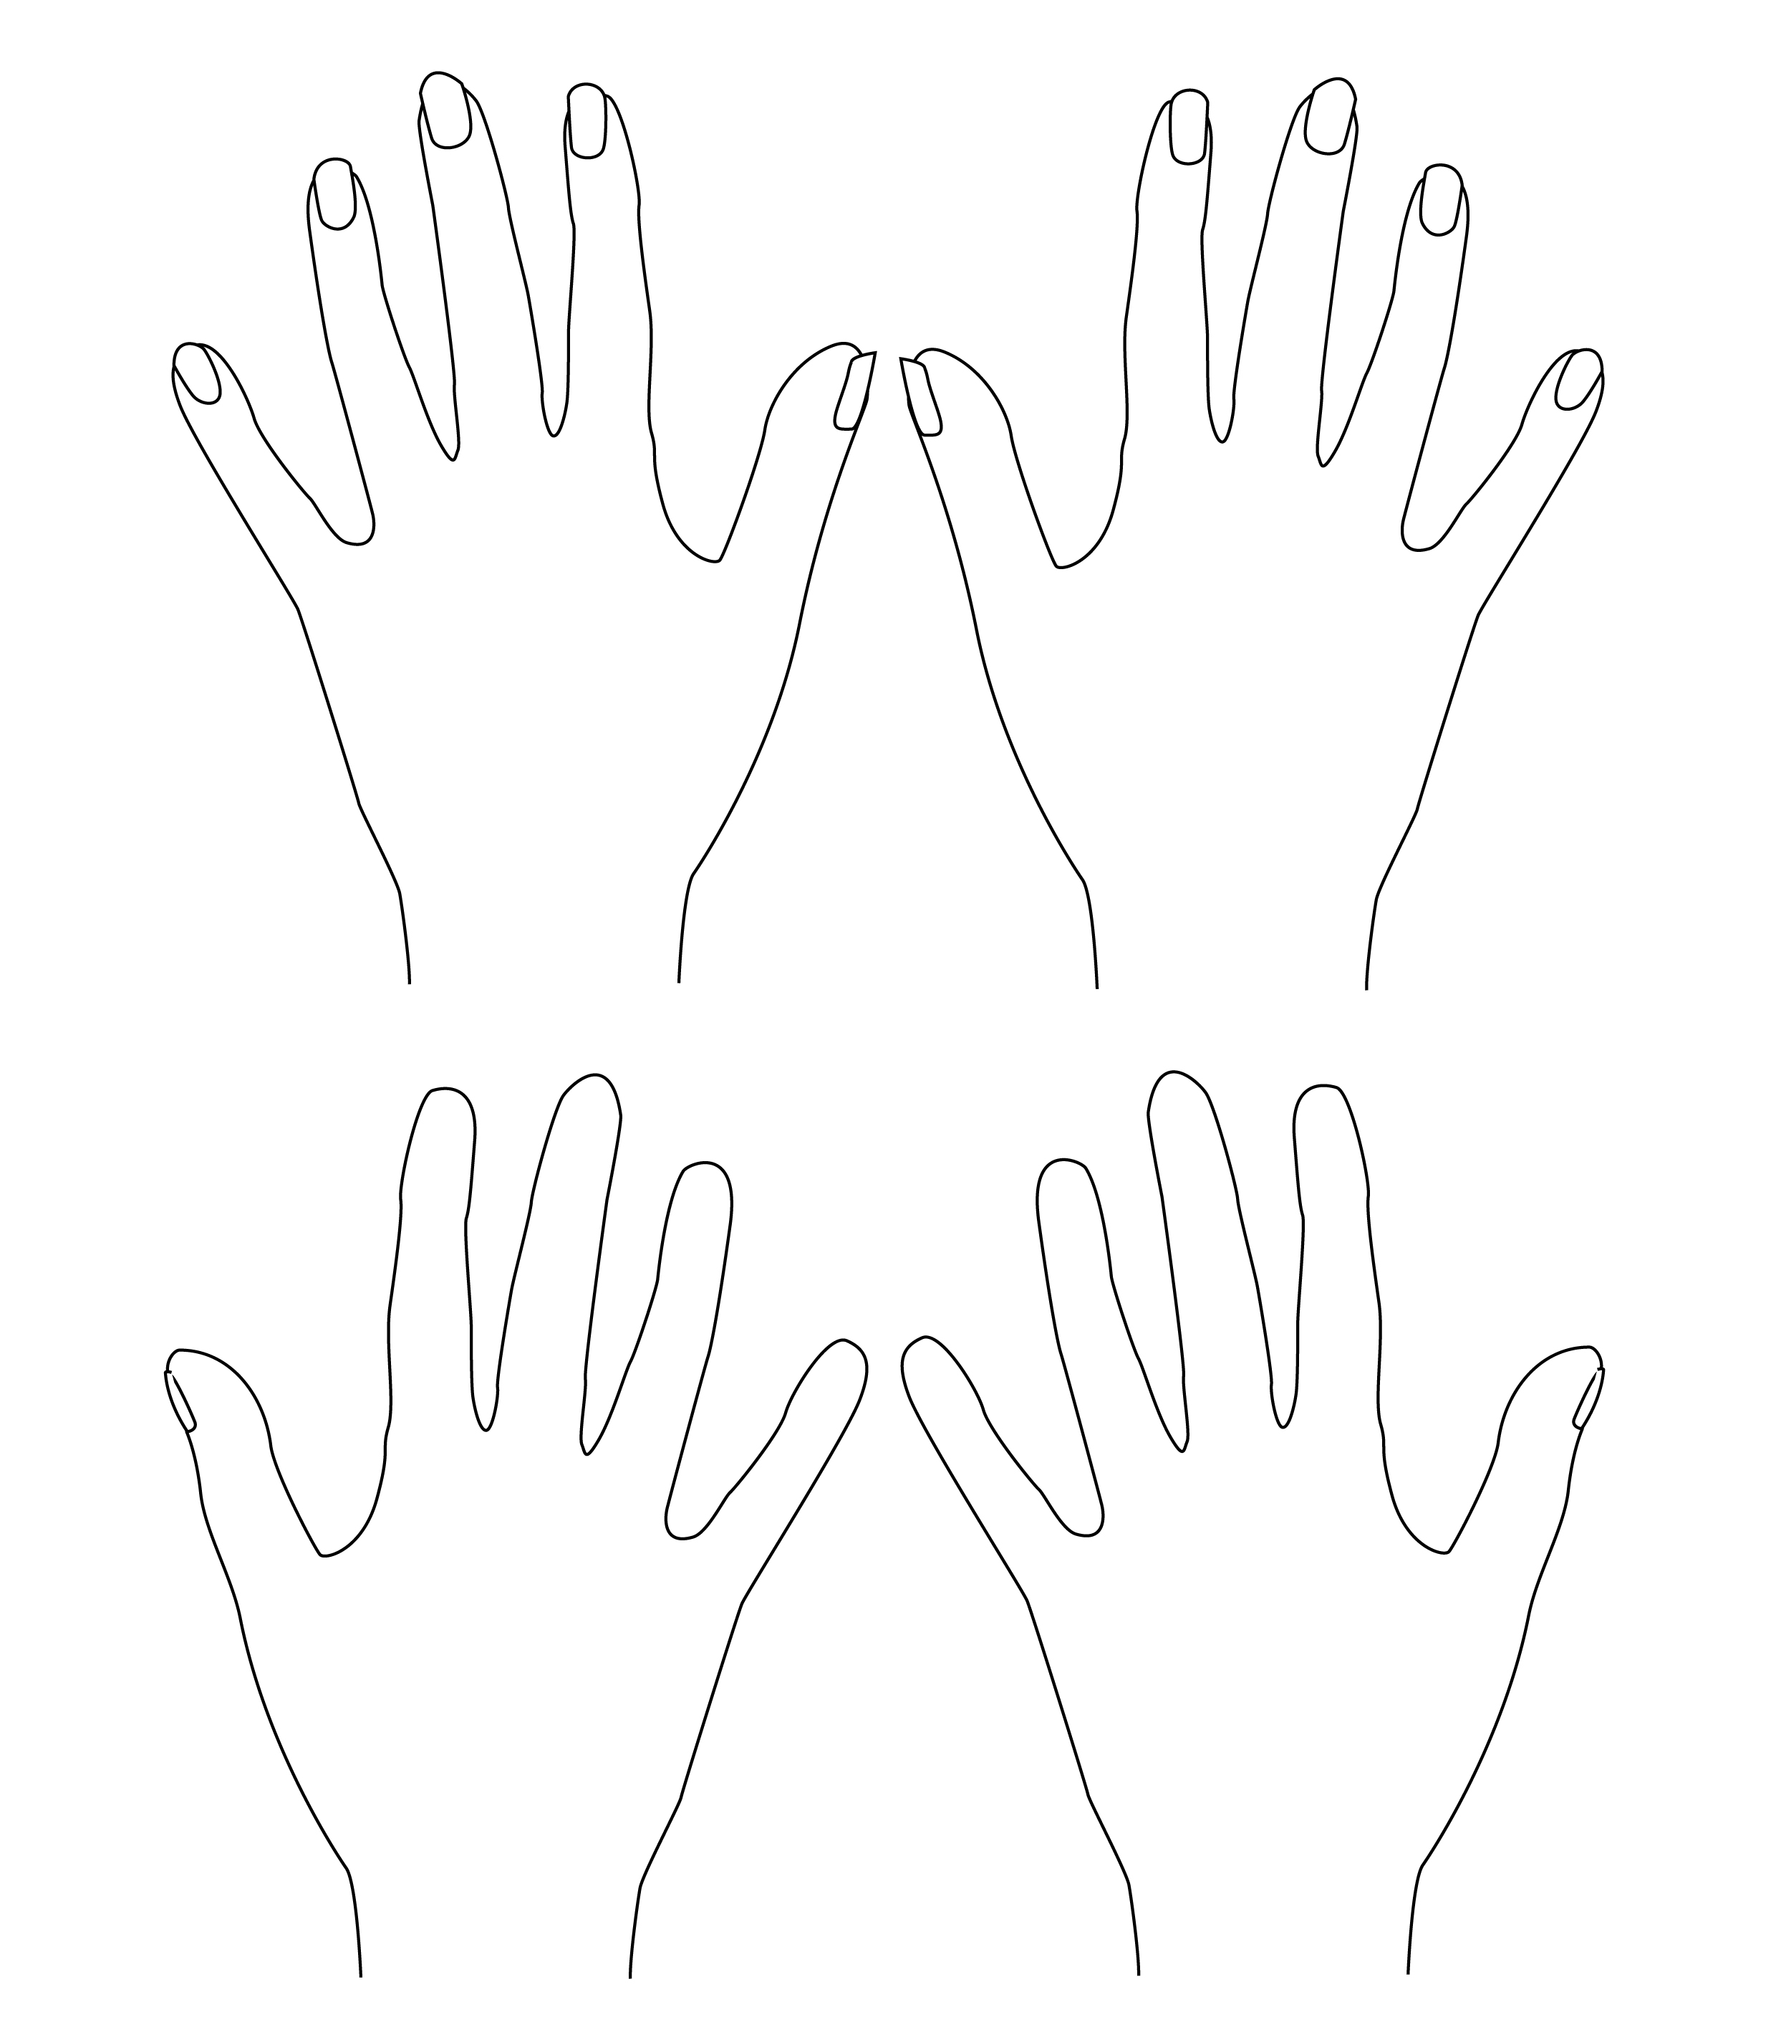
Reflexes |  | Skin Texture |  | Skeletal Problems
Slightly Tender |  | Hard skin |  | Skeletal Deformities | 
Very Tender | ↓ | Taut skin | ||||| | Arthritis
Hard | ◻ | Dry/cracked skin |  | Nail Disorders
Gritty |  | Infections | ◆
Puffy | ⬇ | Damp | ○
 |  | Moles | '

